Announcements

Today |  | FUSION Bible Study |  |  |  |  |  | 9:15am
Today |  | Weekly Prayer Meeting/Pastor's Bible Study |  |  |  |  |  | 9:15am
Today |  | WORSHIP SERVICE |  |  |  |  | 10:30am
Noah's Nursery (Birth-3 years of age) available @ 10:20
4 yrs old-5th graders go to their classrooms after Worship
Today |  | FUSION at Harvest |  |  | 5:30-7:30pm
Wed’s |  | FUSION Intensity  Harvest on Wed nights invite a friend! |  |  | 7:00-8:15pm
Today |  | Home Groups Connect Grow & Learn! |  |  | 5:30-7:30pm
 |  | Hahn’s 11648 SUMMER MEADOWS
  - Upcoming Events
Oct 26th Jones Orchard Corn Maze! 5:30-8:30pm
 | Singleton Parkway - Sunday night Cost $6 per person/ $5 per person if 20+ go. We will eat at Harvest from 5:30-6pm and then head to the Corn Maze. We will return by 8:30pm. Parents: If you would like to help with driving and chaperoning, please let Doug Guizlo or John Strelka know.
Nov 2nd Dinner & Movie Night |  |  |  | 5:00-8:00pm
God’s Not Dead Sunday night
Nov 9th God’s Not Dead Bible Study  (church-wide) For 3 Sunday nights |  |  |  | 5:30-7:30 pm
WANT TO GIVE TO HARVEST?
Tithes and offerings can be given at the wooden box in the rear of the sanctuary. "Each man should give what he has decided in his heart to give, not reluctantly or under compulsion, for God loves a cheerful giver." II Corinthians 9:7
Welcome to

Christian Fellowship

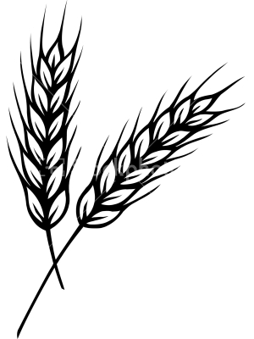
October 19, 2014
Worship – 10:30am
….where you will find a family of believers committed to loving you with the love of Christ. At Harvest, we glorify Jesus through teaching, prayer, equipping, worship, fellowship and outreach.

Then He said to His disciples, “The harvest is plentiful, but the workers are few. Therefore beseech the Lord of the harvest to send out workers into His harvest.“ Matthew 9:37-38

11762 Douglass St. Suites101-104, Arlington, TN 38002
www.harvestarlington.org

God’sBIGPlan & Name
God’s BIG Plan was for:
- A People. (Who would birth the Messiah)
- A Place. (Where many could be reached)
- A Promise. (For anyone who wants salvation.)

TODAY: Moses the Deliverer

Exodus Chapter 1
- The year is about ___________ BC. (SEE I Kings 6:2)
- ________ years have passed since the time of Joseph.
- Israel is now _________________ by Egypt.
Exodus Chapter 2
- Moses is born into the tribe of __________.
- Moses flees Egypt and settles in Midian.
- The Lord _______________ the suffering of His people.
- The Lord has not ____________________ His covenant.
Exodus Chapter 3
God said…
- He would use Moses to ________________ His people.
- “I will certainly ______ ________you”.
- His name is ___ _______.
- His ________________ & ___________would be seen by all.

10.19.2014
Christian Fellowship
Welcome to
Order of Worship
Gathering Time

Nursery | (birth - 3 years old) available at 10:20 am
Welcome & Announcements |  |  |  | Pastor Doug
Praise and Worship

Communion

Children – Please retire to class Ages PreK – 5th Grade
Prayer Time
Prayer Time |  |  | Pastor Doug
** We encourage you to use this time to post and retrieve your Prayer Card on the bulletin Board located to your left in the Sanctuary**
Message
Message – “Moses the Deliverer” |  |  |  |  | Pastor John

